Bryan D’Amico, Surafel Makonnen, Erik Newcome, Adam Vajdak

IST615: Cloud Management

Final Project

# FLDR: A Cloud Powered Document Solution for Educators

## Executive Summary

FLDR, pronounced as folder, is a one-stop cloud powered solution for document organization, management, sharing, and editing for educators. All too often teachers are overwhelmed with the number of tasks they need to get done in a single school day. FLDR wants to relieve the pressure that teachers feel by streamlining their access to student information. Schools can leverage this software as a service application to hold all their student documents in one easy to access location. FLDR will improve the accessibility of documents to different staff members while ensuring that only those who need access have it. It will also increase efficiency related to the record keeping process; reducing potential points of error such as how physical documents can be lost. FLDR promotes a collaborative environment, where staff members can share information quickly and easily, and even update student documentation simultaneously. With the power of FLDR, schools will save time, money, and resources, which can be repurposed to find new ways to help more students.

FLDR leverages cloud technology to give users a web-based interface that accesses their specific school or district database. FLDR provides the storage, maintenance, and security, while users are free to perform their own database management tasks such as creating, deleting, sharing, and editing documents in real time. All changes are saved automatically so there is no worry about documents being missed or out of date.

FLDR will use infrastructure provided by Microsoft Azure Cloud services and will make a return on investment based on subscription fees charged to the users. Users can sign up at either the school or district level and are charged based on the number of accounts and storage used. If a school or district needs to increase the number of accounts or storage, our own cloud solution allows us to easily scale up our service to scale theirs in turn. This will allow us to attractively price the service for schools, while accounting for the operating costs of the service and revenue levels that will allow us to turn a profit.

# Business Proposal

## Identification of Problem

Teaching is a difficult job. One that has only become more difficult with the ever-growing number of regulations and requirements that must be followed. Public schools are inundated with paperwork for each student, including report cards, transcripts, IEPs, 504s, support meeting surveys, standardized testing scores, behavioral and cognitive evaluations, medical and allergy information, and more. Unfortunately, many schools are struggling to keep track of everything using the same paper-based file systems they always have. These schools may continue to use outdated methods because they do not know of another solution. Our goal is to provide a service that can relieve school staff of some of the stress associated with all this paperwork so they can get back to focusing on the parts of the job they enjoy. We know how difficult it can be when teachers and staff do not have immediate access to the information they need. Having everything filed away on paper or simply saved locally on the hard drives of the laptops of various staff members makes it difficult to transfer information and make sure those who need access have it. It is common for each teacher to have close to 150 students among all their classes, and guidance counselors will each serve hundreds of students across all grade levels. At the beginning of a school year, the guidance counselors may find themselves needing to email each teacher various IEP and 504 documents for the students on their rosters. As students change classes throughout the first several weeks of school, it becomes a scramble to make sure all the teachers have the information they need to be informed about what services they are legally required to provide. While students are changing classes, the information that a teacher needs also changes. All these forms changing hands rapidly can lead to unsafe situations that may violate FERPA and HIPAA laws. Emails might get missed, printed out papers might get lost, and in the end teachers, students, and families lose because all that wasted time prevents good teaching and learning from taking place. Teachers lose out on planning time trying to figure out who to contact to get certain forms, and guidance counselors are unable to meet with students or hold support meetings because they are taking time sending out IEPs and other documents.

## Business Case

FLDR is designed with the needs of teachers, counselors, paraprofessionals, school psychologists, administrators, and other school staff in mind. Anyone who interacts with students or needs to handle important documents will be able to enjoy the convenience of these mundane tasks being expedited by a much more agile and robust solution than they’ve experienced before. We want teachers to stop worrying about papers and stop taking time on things other than helping students by using our cloud-based collaborative environment for document storage, management, and sharing. Staff will have instant access to the forms of all the students on their rosters and caseloads. Only those who need to know the information will be able access it with our service following all FERPA and HIPAA regulations by using secure, encrypted storage methods. Each staff member has credentials they use to log in to the database and the size of the database can be set to be on a school or county level depending on the wishes of the school district and board. Now, no more files are printed out or stored locally, reducing the ability of someone being able to steal confidential student information. This service is also entirely self-contained and single purpose, making it clear and easy for even those who are not technologically savvy to know where to go and how to access the forms they need.

Once you are part of our service, your private database can be populated with forms that used to be on paper through an easy upload feature and once all your old forms have been digitized, you can speed things up even further by creating templates for each type of form. Staff can quickly fill out these templates when they need to, save them, and make them immediately accessible to any other staff member who has the students on their roster. This should make all the processes related to each form type more convenient, eliminate anyone emailing confidential forms back in forth, which could put their security at risk, and improve staff productivity related to their primary duties. For example, if a teacher needs to fill out a form for a special education eligibility meeting, they log in to the service, choose the student it is for, fill out the template, and save it. Before the meeting, the guidance counselor logs in, chooses the student, and can see all the forms filled out by the student’s teacher. The counselor now has those forms on hand for the meeting without needing to email anyone or track any papers down. All the participants in the meeting can collaboratively edit the document live and feel confident everything they write is saved and backed up automatically. This turn-key service comes packaged as a web application that links to the database for the school or county and only requires a subscription fee to get started.

## Design of Cloud-based Solution

The FLDR product is designed as a software as a service, where the users pay to access the application through a website user interface. While we maintain and ensure the security of the overall database, the users with the appropriate provisions can perform basic actions and management functions within their partitioned database. This individual database can exist at the school or school district level depending on the scope of the subscription. After a user logs in to the service, they are met with a clean interface that only lists the students they are responsible for. This is set by the school and matches with the determined class rosters and caseloads. After a user selects a student, they can see links to each of the documents contained on that student profile. They also have options to create new files directly on the service. Schools can determine templates for each common file type and users can choose one of those templates as a starting point when creating a new document. If the user selects an already existing file, they can edit it in real time with changes being saved automatically. To boost collaboration between staff, multiple users may make changes to the same document simultaneously.

The following diagram provides a high-level overview of how the architecture of FLDR will function behind the scenes.

The following sections describe the different features, functionality, and support users can expect when choosing FLDR as their record keeping solution.

**Onboarding Strategy**: Once the school or district has determined the estimated amount of volume (which can be scaled up), the onboarding process from the end user perspective is straight forward. The speed and method in which this process can be completed is dependent on the end user school or school district. The school should determine firstly who will have access to the system and what type of access they will need. The owner of the product will purchase and activate licenses at which point they may either provision the Account access to their teams (via email) or provision an Administrator to handle management of the accounts within the product.

**Administrative Access Role**: This will be the most impactful role within the product. Administrators will have unrestricted access to all files, accounts, and objects within the system. They will have the ability to create, alter, and delete any files, accounts, and objects within the system. It is advised that this scope be limited to a select number of users as if this is not used with discretion it can be damaging and will require assistance from technical support to restore any lost or damaged files, access, and accounts. This account can also move files across objects and adjust any ownership to files.

**Teacher Access Role**: This will be a sub-administrative account meaning this account type will not have the ability to delete or adjust role access. This role can create new files and share the files that they own with other objects within the domain, however once these files are shared, the teacher who created them is no longer the sole owner of these files. This role cannot create new objects or delete existing objects within the product, those actions can only be completed by an administrator.

**Viewing Role**: This role is strictly for viewing records and has no create, alter, or delete functionality. Take for example if a long-term substitute teacher needs temporary access to accommodation or medical information to assist a student within the class, this would be a quick solution that an Administrator can provision.

**Creating an Object/Profile**: Within this product, you can create profile or object templates. Taking a student for example, you will most likely need the following data points: full name, date of birth, student I.D., and emergency contact information. Any data point required by the school for record keeping purposes can be templatized and made a requirement by the admin creating the object profiles. Once this is finalized you can quickly click “+Create New Student” to input a new student into the system at which point you may begin uploading records for this student.

**Uploading Existing Documentation**: Once an Administrator has created a profile or object for a student, users are now able to begin uploading documents for that student. This would most likely need to be completed by the school’s clerk in charge of student files. Within our system you can either directly scan into our system, or if these files are already digital, you can simply upload them from your computer hard drive or whatever existing storage service you might be using.

**Training:** Included with FLDR is the ability to schedule a demonstration of the product as well as training sessions for your staff to learn about the product. These will be conducted once licenses have been added and end users have been provisioned their access. Training will be split into groups based on role. We will schedule training sessions via either Zoom, Microsoft Teams, or Google Meet. Within this training, we will go over the product architecture, how to strategize and build your organization within the product, what actions your role has the capability to complete, and how to complete those functions. We guarantee your staff will leave with knowledge about and appreciation for the product due to its ease of access and use.

**Offboarding:** While we cannot conceive any reason why an organization would want to leave our platform, we do understand that this is a possibility. For that reason, we have made it possible to export your data in the form of individual student PDFs and a database migration to a SQL server archive of your specification. This would constitute a one-time event, the terms and conditions of which are spelled out in the Software Support/Service Agreement (SSA) signed by every customer upon purchase of the service. Post migration to the new SQL server archive, we would initiate a complete and irreversible deletion of all data on the cloud environment after 30 days of inactivity.

## Financial Analysis

We analyzed cloud options from Microsoft Azure and Amazon AWS, making sure to select similar features, support models and virtual machine (VM) specifications. All solutions have a single database/application server and 5 Virtual Desktop Infrastructure (VDI) servers for application presentation to the end user. The cloud platforms were specified with a domain controller and will leverage the school’s Active Directory environment via a limited one-way domain trust. In our opinion, the Azure cloud deployment, while the most expensive on an annual basis, offers the best solution from a deployment standpoint. We find Azure’s resource GUI more user friendly and the product offerings more comprehensive. Azure offers world class training and support from a known and trusted vendor.

Microsoft Azure Build Estimate:

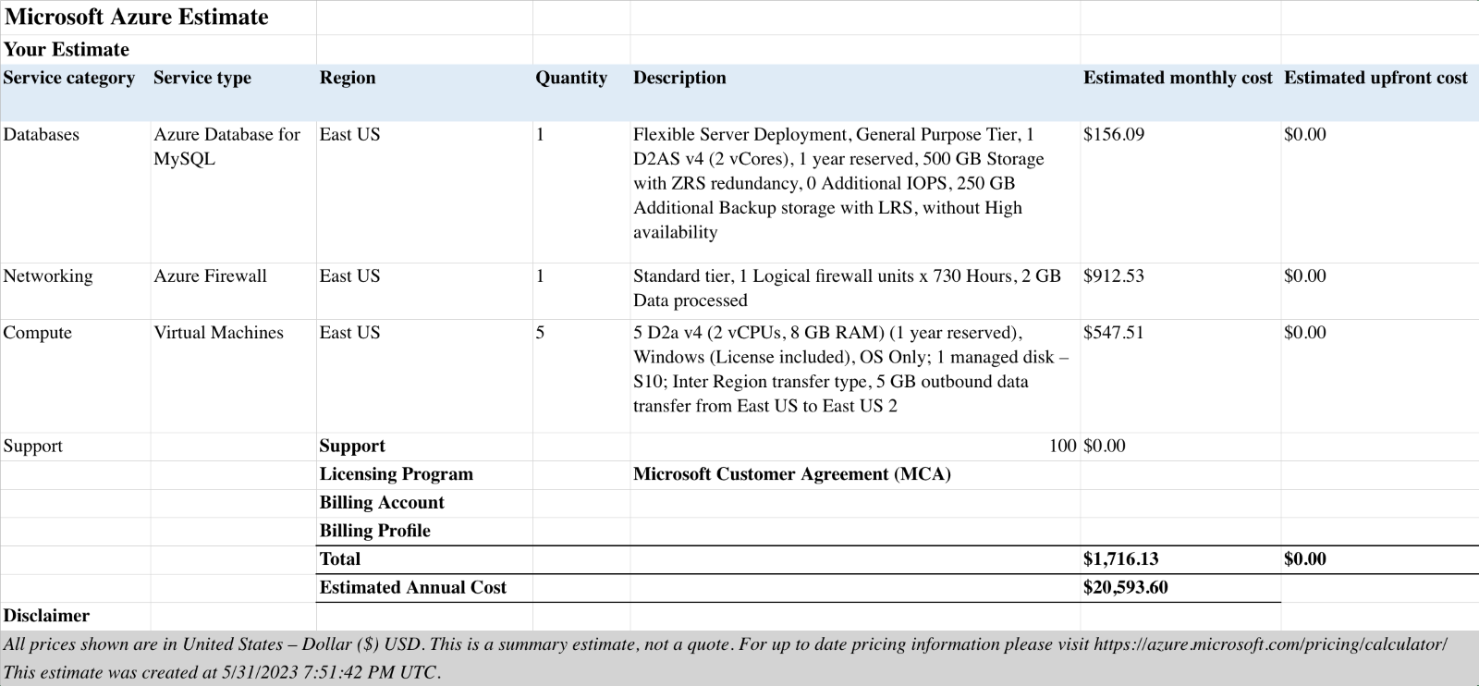

Amazon AWS Build Estimate:

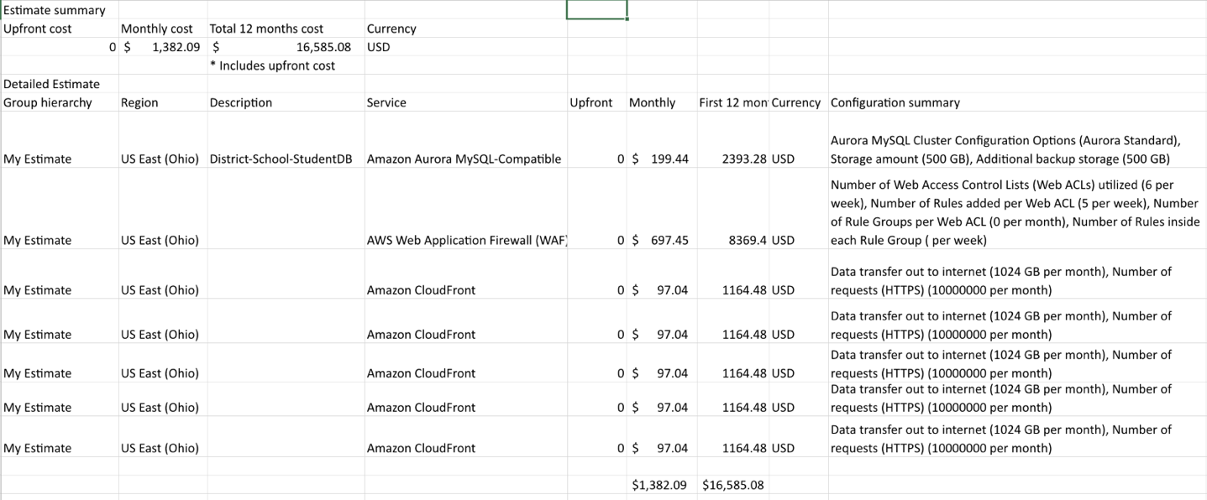

An on-prem solution was also quoted for reference and comparison. This solution includes the bare metal hardware, operating system, and MSSQL for the DB server and a base license set for VMWare Horizons VDI.

|  |  |  |
| --- | --- | --- |
|  | Dell PowerEdge R740 - 2U | Dell PowerEdge R350 - 1U |
| Processor | Intel Xenon Bronze 3206R 1.9GHz, 8C/8T | Intel Pentium G6405T 3.5GHz, |
| RAM | 8GB | 8GB |
| Storage 1 | 480GB SSD | 1TB |
| Storage 2 | 300GB HDD | n/a |
| OS | Window Server 2022 Standard | Windows Server 2022 Essentials |
| Addl SW | MSSQL 2019 | VMWare Horizons |
| Quantity | 1 | 5 |
| Cost w/ SW | $14,717.89 | $13,066.67 |
| Total On-Prem Cost | $27,784.56 | |

The benefit of an on-prem solution is that there is little FY2 and FY3 operating cost outside of maintenance. The FY1 cost was still in line with the cloud offerings, but this is only half of the financial picture as we did not calculate in the cost of housing the servers in the datacenter, the overhead for the Systems Administrator to maintain them, and the potential cost of downtime when a component breaks.

The on-prem option would only be viable if the customer already has the infrastructure, in-house expertise and willingness to take on the six server deployment. This option would require the customer to have their own datacenter or contract with another vendor providing this service. The AD domain trust would still be leveraged in this second scenario though adding to the complexity of the install and maintenance. The level of comfort allowed by making a single phone call to the vendor in the event of a down system or issue greatly reduces the stress and workload on the customer’s administrative, teaching, and technical staff freeing them up to doing what they do best: educating the next generation of innovators.

## Call for Action

It has always been difficult for schools to have access to the best technical solutions. As technology advances, the lack of funding makes it difficult for the public education system to keep up. Without that funding, schools often find themselves left in the past working with antiquated systems that are not able to scale with the increasing number of students and responsibilities. By leveraging FLDR as a cloud-based solution, schools can centralize all student documentation and enjoy several important benefits. FLDR will enhance a school or district’s efficiency, streamline administrative tasks, and improve each student’s educational journey. So much valuable time is wasted worrying about manual record keeping and documentation, and now all that time can be repurposed for better uses. We believe FLDR will benefit schools in five key ways:

1. **Saving time and money:** Implementing FLDR as a centralized documentation system will reduce time and effort spent on manual record keeping. Also, any physical spaces that were used to keep records can now be repurposed to address other needs. The saved space and budget could go towards creating an additional student resource room or photocopying center for teachers.
2. **Enhanced Accessibility:** The cloud-based solution ensures that all documents can be easily encapsulated within a single student profile. These documents are available from any device, exactly when the authorized parties need that information. This allows administrators, teachers, counselors, and paraprofessionals to meet the needs of their students without the usual hassle of figuring out what those services are. FLDR makes communicating with parents and families easier as well. With all the documents in one place, any staff member knows exactly where to go to update a student’s family on important matters like eligibility results, standardized testing scores, and special education services. Also, having historical data on each student throughout their educational journey helps the school build longer lasting relationships with the community it serves.
3. **Efficient Record Keeping:** Storing potentially thousands of records on paper is time consuming and prone to human error. By centralizing student documentation in the cloud, data entry is much faster, the risk of files being misplaced in other students’ records is significantly lowered, and losing the primary copies of documents is a thing of the past. Increasing the speed at which information can be relayed throughout the school and to families while also improving the accuracy of that information is a great win for the school and for students.
4. **Collaboration:** School staff now can easily share information about their students quickly and efficiently. Having historical data on each student accessible throughout their education journey helps teachers foster better relationships. If FLDR is being utilized centrally within a school district, this information is easily transferrable between schools should the child move to a different school within the same district. This creates seamless and effortless transitions for children and families as they move through the different grade levels. The files in FLDR can also be accessed and edited simultaneously making it easy for teachers to share notes, ideas, results, and more.
5. **Refocusing Responsibilities:** By removing the manual aspects of record keeping, school staff can focus on other tasks. Teachers can reclaim their planning periods to improve their instruction. Counselors can meet with more students and hold more support meetings. Paraprofessionals will have more time to be in classrooms engaging with students. Administrators will have more time to meet with teachers, visit classrooms, and form better relationships with staff and students. All this culminates in a better school culture that benefits learners.

In summary, implementing a centralized cloud solution for files and documents offers many advantages for the school, students, and families. The efficiency of FLDR saves the school time and resources which can be repurposed to create a better learning experience for each student. This creates a better work environment for staff, administrators, and teachers as they have easy access to necessary information for their students. This also makes communication with parents much easier for the school and improves its relationship with families. By making FLDR affordable, easy to implement, and quickly scalable, it can grow into a dominant cloud solution in the education field.

Our goal is to acquire $10 million in total funding to get FLDR fully developed and rolled out to schools. We feel that this would provide us capital to work with over a three year start up period. We would like to hire an initial team of 8 people consisting of software developers, cloud IT staff, and a project manager. To attract good talent, we are accounting for competitive salaries of $100,000 per year on average. After provisioning roughly $25,000 per year for Azure, the rest of the money will be reserved for paying for advertising costs and travel expenses to visit schools and talk to customers. Some services like Blackboard cost over $150,000 per year. If we price a yearlong subscription to FLDR very competitively, resulting in an average charge of $2,000 per school, we feel we can begin to build a customer base. If after three years, we are even working with just 3% of the over 90,000 public schools in the United States, we would be generating approximately $5.4 million in revenue each year. This revenue would allow us to start expanding our team to accommodate more customers and spur more growth. If in the long term we just have 10% of the public schools as customers, that would generate more than $18 million in revenue per year with comparatively negligible costs to scale up our infrastructure. We feel that as more schools enjoy the ease, accessibility, and speed afforded by FLDR, the customer based will quickly expand. We hope that you see the same potential in this technology that we do and that you choose to embark on this journey with us.